20MCA136 – NETWORKING & SYSTEM ADMINISTRATION LAB Dept. of Computer Applications

|  |
| --- |
| **Name: VYSHNAV SURESH**  **Roll No: 56**  **Batch: B**  **Date: 05-05-2022** |

**NETWORKING & SYSTEM ADMINISTRATION LAB**

**Experiment No.: 10**

**Aim**

Write a shell script to find largest of two numbers.

# Program

echo "Enter the value of a" read a

echo "Enter the value of b" read b

if [ $a -gt $b ] then

echo "a is greater than b"

else

echo "b is greater than a"

fi

# Output Screenshot

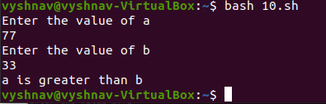

Amal Jyothi College of Engineering, Kanjirappally